I'm going to do something a bit different this month. Instead of creating a new sample application, I am going to update an existing one. The result is an improved Recycle Bin application.
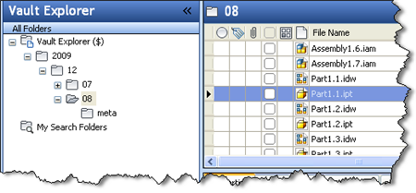
(click image for full view)
Click here to download the application
Click here to download the source
What's new
- Multiple versions of a file can be backed-up when the recycle bin is emptied. Previously only the latest version would get backed-up.
- The metadata for each version is stored. This includes:
  - Folder information
  - Property information
  - Revision information
  - Lifecycle state information
  - Parent and child file associations
  - BOM information
- A new command line option, –O, which controls which versions get backed up.
Installing for the first time
Download version 1.1 from this page, then follow the instructions from the original blog post.
Upgrading from version 1.0
Download version 1.1 from this page, then overwrite the existing RecycleBinUtil.exe. Add the –O option to your scheduled task command if needed (see readme).

